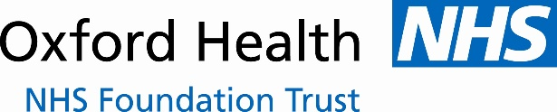
School Health Nurses
Abingdon Community Hospital
Marcham Road
Abingdon
OX14 1AG

Pre-measurement letter to parent/carers
Spring & Summer Terms 2023
NCMP DATE: Friday 31st March 2023.

Height and weight checks for children in Reception and Year 6
Every year, over 17,000 schools take part in the National Child Measurement Programme (NCMP). Your school is one of these, and as part of that, your child will have their height and weight checked in this year’s programme.

In conjunction with over one million other children’s measurements, your child’s measurements will then be used to gather information about children’s growth and weight patterns across the country, and this will help inform the development of actions, services and programmes to benefit children in Oxfordshire and countrywide.

You’ll also receive information about your child’s measurements, along with links to services or resources that could be useful for the health and wellbeing of your child and family. Some of these links are included in this letter.

All this information is treated confidentially and held securely. No individual measurements will be given to your child, any staff members at school, or other children.

Maintaining the wellbeing of children in the NCMP
Your child’s wellbeing is of paramount importance, and as such, a number of measures are taken to ensure these measurements are taken in a safe and sensitive way.

The checks are carried out by trained members of the school health nurse team. Children are measured fully clothed, except for their coats and shoes, in a private space away from other pupils.

The programme will be delivered in a COVID-safe way, in line with the school and local authority’s safety control measures.

The emotional impact of the NCMP has been researched and studies show that body image, self-esteem, weight-related teasing, and restrictive eating behaviours do not change as a result of being measured or receiving feedback. In addition, most children report being indifferent or unconcerned about being weighed or measured.

If you are concerned about your child’s growth, weight, body image or eating patterns, please seek further support from a school nurse or General Practitioner, or one of the organisations specified in the links section of this letter.

What happens after the measurements have been taken
Your child’s measurements will be shared with you via a letter which you will receive in the post. The results will not be shared with your child, or with their school. It is your choice if you wish to share the information with your child or not.

The information collected from all the schools in your area will also be gathered and held securely, so it can then be analysed to inform decisions about policy, strategy, programmes and services which can benefit the health and wellbeing of children and families around Oxfordshire.

We may also store your child’s information as part of their local child health record on the NHS’s child health information database and may share it with their GP.

All information is treated confidentially and securely. Full details of information collected and how it is used is outlined in the sections below.

Withdrawing your child from the National Child Measurement Programme
If you are happy for your child to be measured, you do not need to do anything.

If you do not want your child’s height and weight to be recorded, please contact us directly using the contact details provided below.

Your contact from the School Health Nurse team is:

Staff Name: Amy Ellis Mobile No: 07557 204192

Children will not be made to take part on the day if they do not want to.

Medical conditions affecting your child’s height and weight
If your child has a medical condition which affects their height and weight but still wish for your child to be measured on the day, please contact us on the details above and we will be happy to discuss this with you.

The information we collect and what it is used for
- Your child’s name, date of birth and NHS Number are used to link your child’s measurements in Reception and Year 6. Other data sets held by NHS Digital and Department of Health and Social Care may also be linked as this would let us add information from health and education records, where lawful to do so, to understand how and why the weight of children is changing, and how this affects children’s health and education and how we can improve the care children receive.
This includes your child’s health data relating to;
  - Their birth, hospital care (including time in hospital and out-patient appointments and diagnosis of medical conditions)
  - Mental health
  - Social care
  - Primary care - includes all healthcare outside of hospital such as GP and dental appointments,
  - Public health - including data relating to preventing ill health such as immunisation records
  - Records for when and the reason why people pass away
  - Medical conditions such as cancer, diabetes
  - Health, lifestyle, and wellbeing surveys that your child has participated in
- your child’s ethnicity and address are used to help understand some of the reasons for the difference and changes in child weight across England
- your address is required to send you your child’s feedback letter, please ensure school have your current address. This will include your child’s measurements together with information about healthy eating, being active and related activities available in your area.

All the data collected is also used for improving health, care and services through research and planning. All this information is treated confidentially and held securely. No individual measurements will be given to school staff or other children.

How the data is used
The information collected from all schools in the area will be gathered together and held securely by Oxford Health NHS Foundation Trust and NHS Digital. We will store your child’s information as part of their local child health record on the NHS’s child health information database and may share it with their GP.

All the information collected about your child will be sent by us to NHS Digital. NHS Digital is responsible for collecting data and information about health and care so that this can be used to monitor and improve the care provided to people across England.

The information collected about your child will also be shared by NHS Digital with Public Health England but in a de-personalised form only. This means Public Health England will not be able to identify your child. Public Health England is responsible for working to protect and improve the nation’s health.

Both NHS Digital and Public Health England will use the information from the National Child Measurement Programme to better understand numbers and trends in child weight and body mass index (BMI). This helps with the planning of services to support healthy lifestyles in your area. No information will ever be published by NHS Digital or Public Health England that identifies your child.

De-personalised information from the National Child Measurement Programme may also be shared by NHS Digital with other organisations, such as universities. This is to help improve health, care and services through research and planning. This information cannot be used to identify your child, and NHS Digital only ever shares information for research with the approval of an independent group of experts.

Further information and support
The following pages contain some useful links to explain more about the National Child Measurement Programme and the data flow for the information collected, as well as links to valuable online or community services that are available to support you and your family. We hope you find them useful.

Yours faithfully,

Dr Ansaf Azhar Emma Leaver
Director of Public Health Director of Children’s Services
Oxfordshire County Council Oxford Health NHS Foundation Trust

Further information, resources and support

How your child’s data is collected and processed as part of the National Child Measurement Programme (NCMP)
Local authorities have a legal duty to collect the NCMP data. They do this by following guidance from Public Health England. Local authorities are responsible for making decisions on how the data is collected and for making sure it is protected. Local NCMP service providers are contracted to carry this out; this might be through the school nursing team working in schools or a local healthcare provider. The team collecting the data enter it into the NCMP IT system, which is provided by NHS Digital. The data may also be entered into a local child health information system. Your local authority is responsible for sending the data to NHS Digital. NHS Digital and Public Health England are jointly responsible for the data held at a national level. Your local authority is responsible for the data held locally.

The chart below displays what happens to your child’s data as part of the NCMP:

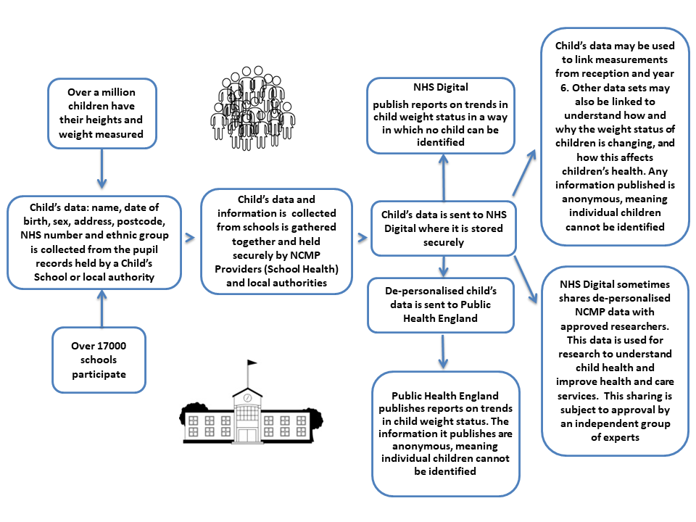

Links to find out more
Further information about the National Child Measurement Programme can be found at https://www.nhs.uk/live-well/healthy-weight/national-child-measurement-programme

Information about how we, Oxford Health NHS Foundation Trust collect and use information can be found at www.oxfordhealth.nhs.uk/privacy/

Information about how NHS Digital and Public Health England collect and use information can be found at https://digital.nhs.uk/about-nhs-digital/our-work/keeping-patient-data-safe/how-we-look-after-your-health-and-care-information and https://www.gov.uk/government/organisations/public-health-england/about/personal-information-charter

Information about the organisations NHS Digital has shared information from the National Child Measurement Programme can be found at https://digital.nhs.uk/services/national-child-measurement-programme

Fun ideas and free support to help your child eat well and stay active
Information and fun ideas to help your kids stay healthy can be found at
https://www.nhs.uk/healthier-families/

Information about Oxfordshire’s brand-new child weight management programme, with fun activities for the children, and practical information for the parents, can be found at https://www.achieveoxfordshire.org.uk/services/gloji-energy

Information about how eligible families can access free or discounted activities in their area can be found at https://www.getoxfordshireactive.org/you-move

